alfa 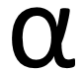

beta 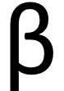

gama 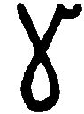

delta 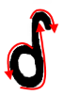

epsilon

alfa

beta

gama

delta

epsilon

